Tutorial 8
PreDCR Conversion of School Building Drawing
(Educational Use (SpecialUseFSI), Ground+7 Upper Floors building, Refuge Area.)

How to convert Residential PreDCR drawing for preparation of submission drawing?

- How to start PreDCR?
- Double-click the PreDCR Maharashtra_Print icon on your desktop.
- The following screen will pop up for the selection CAD version.
- Please select the CAD version to run the PreDCR.

- PreDCR Toolbar and PreDCR Menu will be loaded in the CAD Application.

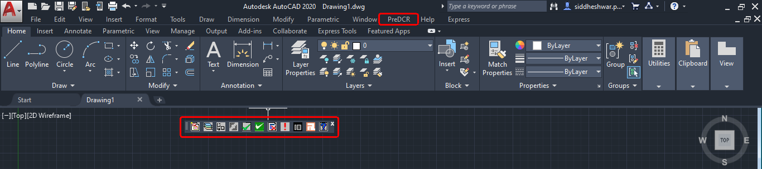
- How to create a ‘New Project’ and ‘Insert’ printing layout sheet?

- Open the drawing file form ‘Open File location’
- Click on the first tab available in the PreDCR toolbar ‘Create a new project for current drawing’.
- This command will ‘Create New project’ for the current drawing.
- ‘Project Information ‘window to select ‘Type of Project’ from the dropdown.
- Here, ‘Type of Project’ = ‘Building Development’ is selected.
- Tick on ‘For Printing do want to insert page size block’

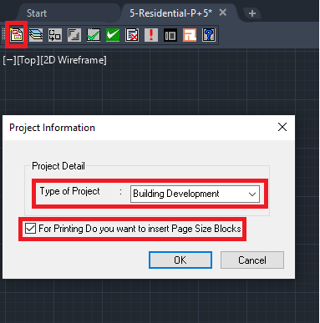

- Click ‘OK’ after selecting the type of project and insert printing page size block.
- Select the first layout insertion size as per drawing size
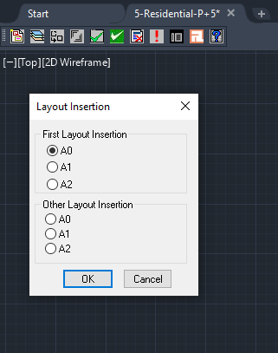
- Select the first layout insertion size as per the drawing size.
Note: Insert required nos of layout sheets.
- Specify the layout insertion size in model space, printing layout sheet automatically inserts model space as per the selected size.

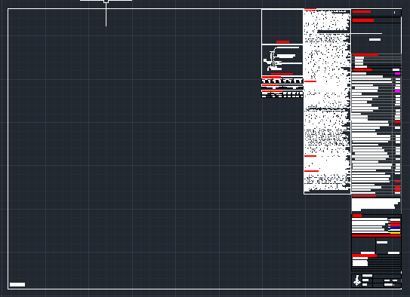
NOTE: All PreDCR conversion should be done in inserted layout sheet with closed polylines on a 1:1 metric scale as follow:

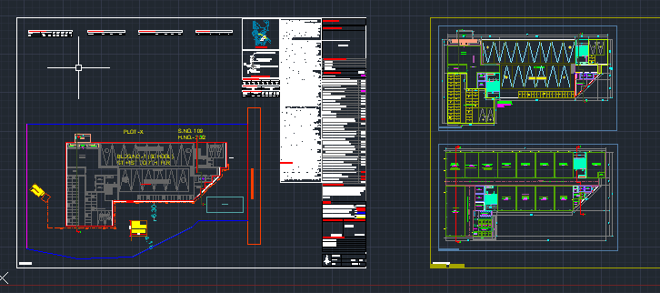

- How to Create Layers in the drawing?
- Click on the 2nd tab ‘Create DCR Layers in the current drawing’.
- This tab will create layers required for drawing conversion as per the selected ‘Type of Project’.
- Click on ‘Yes’ in the PreDCR dialog box.
- For the proposed development type software will generate the standard set of layers for drawing conversion.

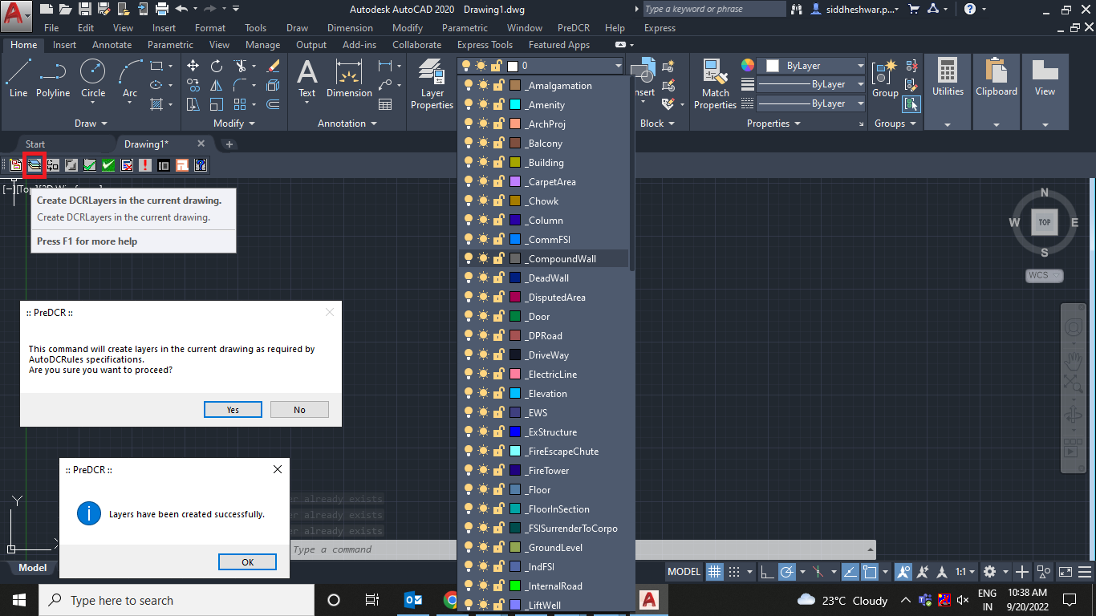

- How to convert PreDCR drawing?
Let’s learn the PreDCR drawing conversion.

This tutorial will explain the conversion process of an educational building with a Ground + 7 Upper Floors and a Refuge area.

  - Let’s start with the ‘Site Plan’ Conversion.

4.1.1. How to draw the ‘_MainPlot’ layer?
- Go to layers drop down Select the ‘_MainPlot’ layer.
- Draw plot outline in closed polyline on the ‘_MainPlot’ layer.
- Give MText for ‘Plot Number/Name’.

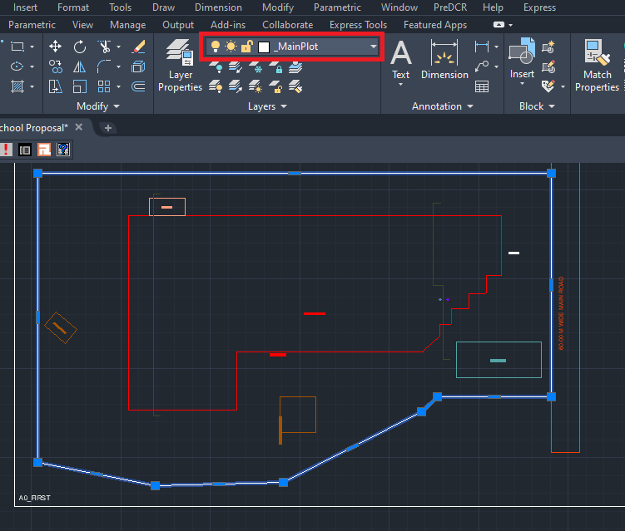

4.1.2. How to draw the ‘_MainRoad’ layer?
- Go to layers drop down Select the‘_MainRoad’ layer.
- Drthe aw main road in a closed polyline on the ‘_MainRoad’ layer.
- ‘_MainRaod’ layer should exactly overlap with the ‘_MainPlot’ layer.
- Give MText for ‘Road name with road width’
For ex. – Here in the sample drawing – ‘60.00m Wide Main Road’ is written.

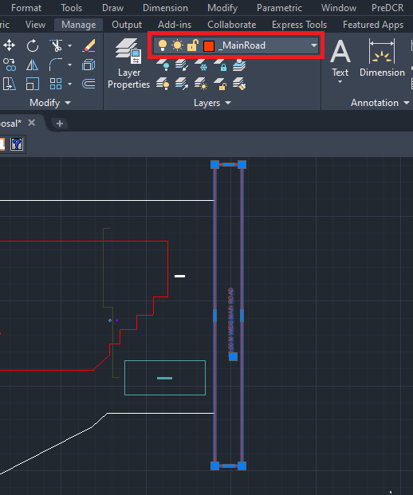

4.1.3. How to draw ‘_PWork’ lay
- Go to layers drop down Select the ‘_PWork’ layer.
- Draw proposed work/building outline in closed polyline on the ‘_PWork’ layer.
- ‘_PWork’ layer should be drawn inside the plot poly/site plan.
- PWork is a building profile and shall be drawn inside the plot.

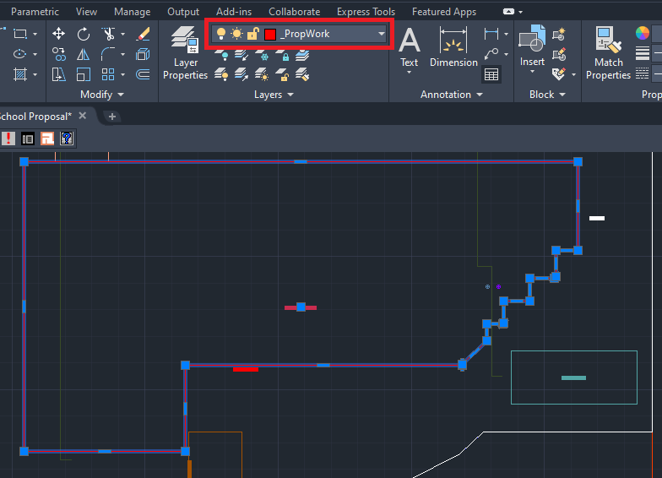

4.1.4. How to draw a ‘Section line’ on PWork?

- Go to layers drop down Select the ‘_Sectionline’ layer.
- Draw polying through the PWork on the ‘_Sectionline’ layer and give MText as ‘Section A-A’ as drawn in the drawing.

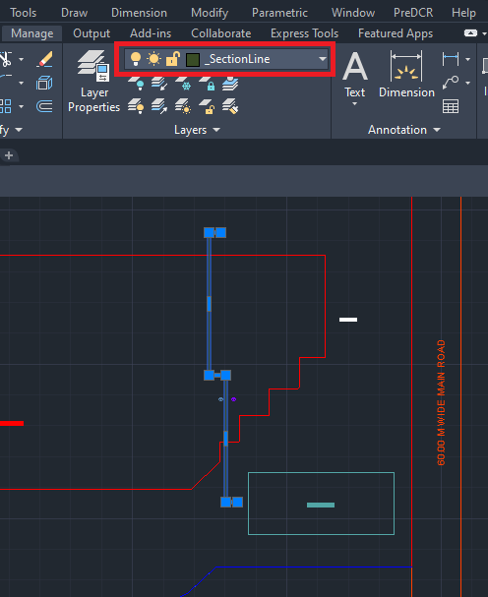

4.1.5. How to insert ‘Common reference circle’?
- Go to layers drop down Select the ‘_RESIFSI’ layer.
- Select the ‘_ResiFSI’ layer to insert a common reference circle.
- Go to menu bar PreDCR menu drop down Select ‘Insert’ Select ‘Common reference circle.
- Common reference circle is mandatory to insert on the same point in every floor plan and in the site plan.
For ex: Select common space available on every floor like a staircase OR lift location

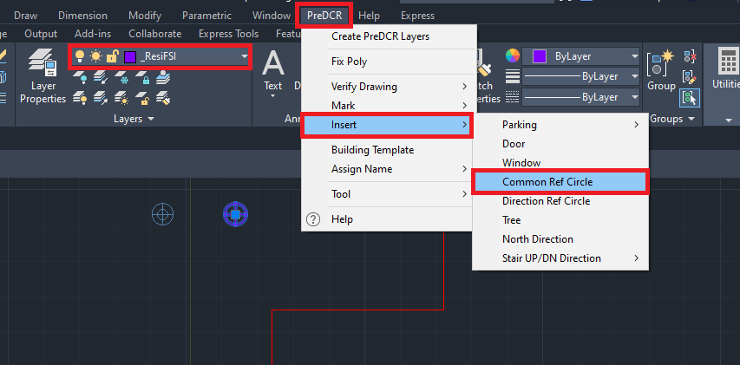

4.1.6. How to insert ‘Direction reference circle’?
- Go to layers drop down Select ‘_Floor’ layer.
- Select the ‘_Floor’ layer to insert the direction reference circle.
- Go to PreDCR menu drop down Select ‘Insert’ Select ‘Direction reference circle’.
- Direction reference circle is mandatory to insert at the same point in every floor plan and in the site plan.
For ex: Select common space available on every floor like a staircase OR lift location

Note:
Both direction and common reference circle are to be inserted together/next to each other at the same point.
Please refer to the below daring screenshot.

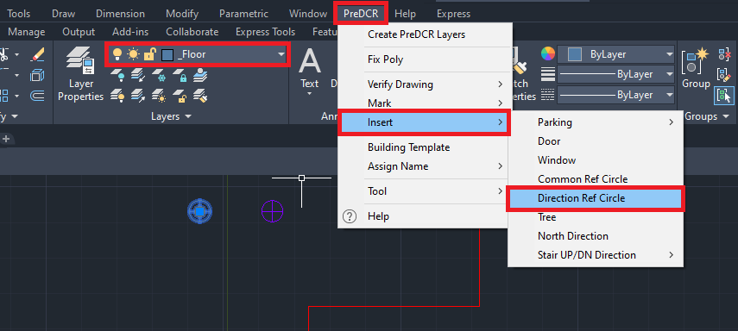

4.1.7. How to draw the ‘_Sub Structure’ layer?
- Go to layers drop down Select the ‘_Sub Structure’ layer.
- Draw proposed substructures on the site plan in closed polyline on the ‘_Sub Structure’ layer.
- ‘_Sub Structure’ layer should be drawn inside the plot poly/site.
- ‘_Sub Structure’ layer should be marked with an available option in the PreDCR menu dropdown.
- For marking ‘_Sub Structure
Go to PreDCR MarkSub StructureRain Water Harvesting
Here, as per the sample case, Rain Water Harvesting is selected.

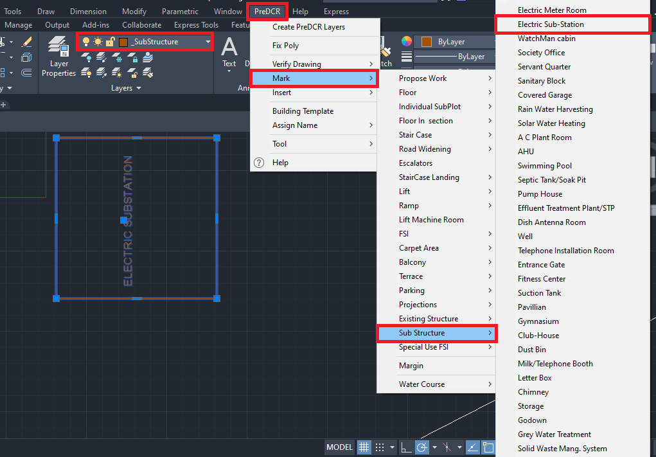

Note:
All types of substructure marking options are available in the dropdown, please select as per the proposal.

4.1.8. How to draw the canopy in the ‘_ArchProj’ layer?
- Go to layers drop down Select the ‘_ArchProj’ layer.
- Canopy plan should be drawn in closed polyline overlap with PWork poly and canopy height/section must draw in section block on the ‘_ArchProj’ layer.
- For marking canopy drawn in the ‘_ArchProj’ layer
Go to PreDCR MarkProjectionRain Water Harvesting
Here, as per the sample case, Rain Water Harvesting is selected.

Canopy in the ‘ArchProj’ layer the on Site Plan

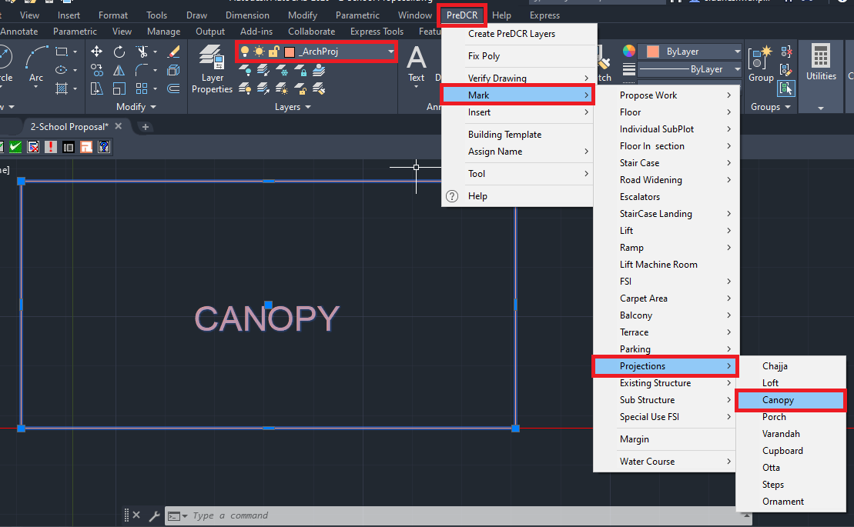

Canopy in the ‘ArchProj’ layer on Section Block
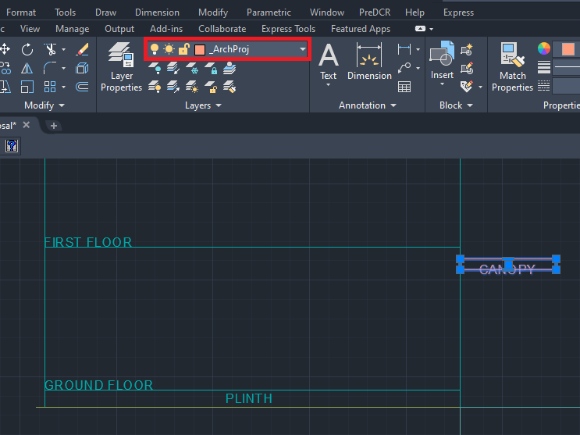

4.1.9. How to draw the ‘_Tank’ layer?
- Go to layers drop down Select the ‘_Tank’ layer.
- Draw the proposed tank in a closed polyline on the ‘_Tank’ layer.
- ‘_Tank’ layer should be drawn in the main plot poly/site plan.
- ‘_Tank’ layer should be assigned a name with an available option in the PreDCR menu.
- For Assign Name to ‘_Tank’ layer
Go to PreDCR Assign NameTank.
- In the Tank name information dialog box:
Fill up the tank information as per the proposal.
For ex: ‘Tank position’= Underground, ‘Tank name/no’=UGWT-1
- Similarly assign a name for ‘Overhead Tank’ as follow:
Go to PreDCR Assign NameTank.
- In the Tank name information dialog box:
Fill up the tank information as per the proposal.
For ex: ‘Tank position’= Overhead, ‘Tank name/no’=OHWT-1

UGWT-1 on Plot Level
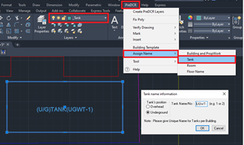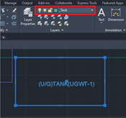

OHWT-1 in Section Block

Note:
After adding tank information, select both tank polylines drafted in the site plan and section for assigning.

4.1.10. How to insert North Direction?
- Go to layers drop down Select the ‘_Location Plan’ layer.
- To insert North Direction:
Go to the PreDCR menu Select ‘Insert’ Select ‘North Direction’ Specify Insertion
Point in the drawing.

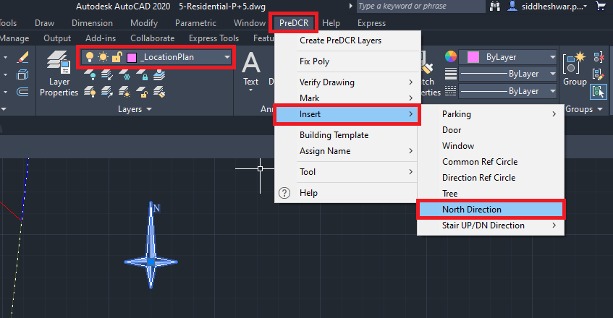

  - Let’s start the ‘Ground Floor’ Conversion.

4.2.1. How to draw the partial parking and habitable use on the same floor in the ‘_Parking’ & ‘FSI’ layer?
- Go to layers drop down Select ‘_Parking’ layer.
- Draw the proposed parking area outline in a closed polyline on the ‘_Parking’ layer.
- Give MText as ‘Parking’ as proposed.

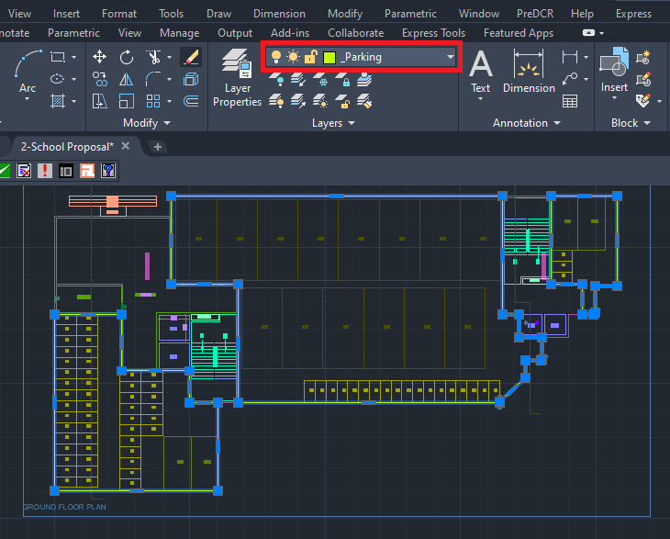

- Go to layers drop down Select the ‘_SpecialUseFSI’ layer.
- Draw a habitable area/built-up area outline in a closed polyline on the ‘_SpeicalUseFSI’ layer.
- For marking of ‘_SpeicalUseFSI’ layer:
Go to the PreDCR menu Select ‘Mark’ Select ‘FSI’ Select ‘Normal (Default)’.
For the existing floor in case of addition/alteration case
Go to the PreDCR menu Select ‘Mark’ Select ‘FSI’ Select ‘Existing FSI’.

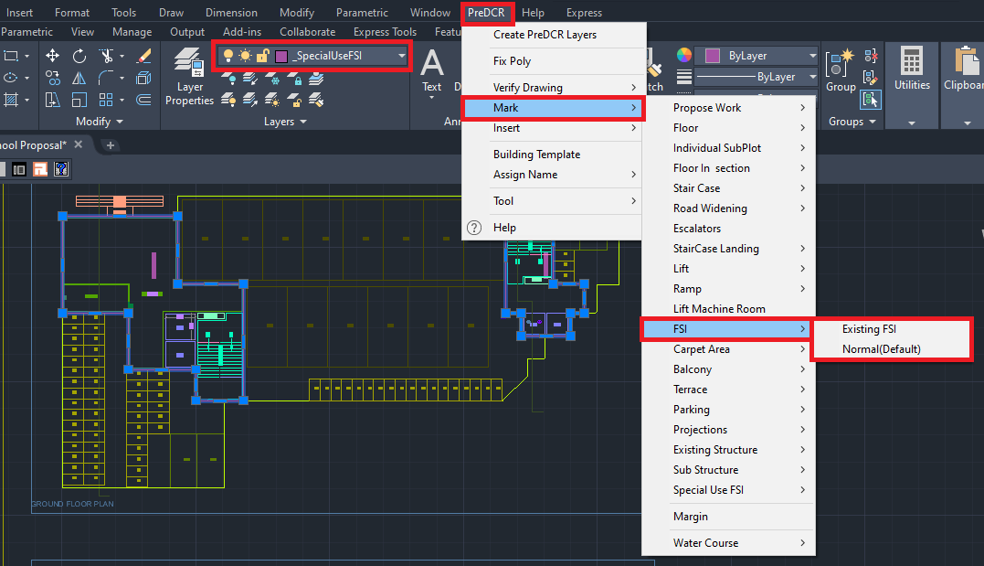

4.2.3. How to insert the individual car OR bus parking inside the ground floor?
- To insert the individual car OR bus parking :
Go to PreDCR menu Select ‘Insert’ Select ‘Parking’ Select ‘Car’ Select ‘Large Car’ Select Floor/ Main Plot poly Specify insertion pointSpecify number for individual parking.
To insert the bus parking follow the above same process and insert car, scooter, and bus as per the proposal requirement.
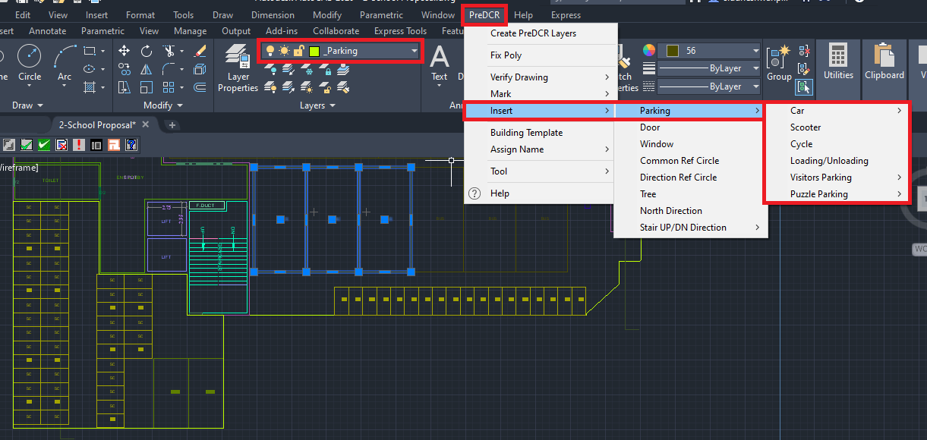

4.2.4. How to draw the ‘_LiftWell’ layer?
- Go to layers drop down Select the ‘_LiftWell’ layer.
- Draw a lift well on an inner side ia n closed polyline on the ‘_LiftWell’ layer.
- For marking of ‘_LiftWell’ layer:
Go to PreDCR menu Select ‘Mark’ Select ‘Lift’ Select ‘Lift Default’.
Options available to mark the lift:
LiftLift Default.
LiftCar lift
LiftMRL
LiftHydraulic lift
LiftFire lift
LiftFireman lift
Select marking options as per requirement.

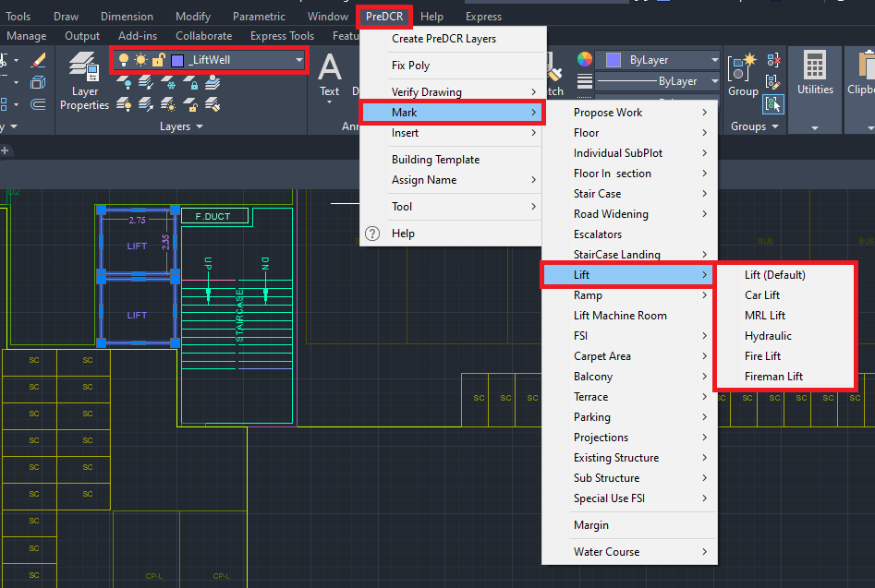
4.2.5. How to draw the ‘_Staircase’ layer?
- Go to layers drop down Select the ‘_Staircase’ layer.
- Draw a staircase block on the inner side in a closed polyline on the ‘_Staircase’ layer.
- ‘_Staircase’ poly should contain Intermediate Landing, and Floor Landing & Each Tread as an open polyline.
- For marking of ‘_Staircase’ layer:
Go to PreDCR menu Select ‘Mark’ Select StaircaseStaircase (Default
Options available to mark the Staircase:
StaircaseNo of flight 3 Flight OR 4 Flight
StaircaseStaircase (Default)
StaircaseOpen Staircase
StaircaseFire escape staircase
StaircaseFab/Spiral stair
Select marking options as per requirement.

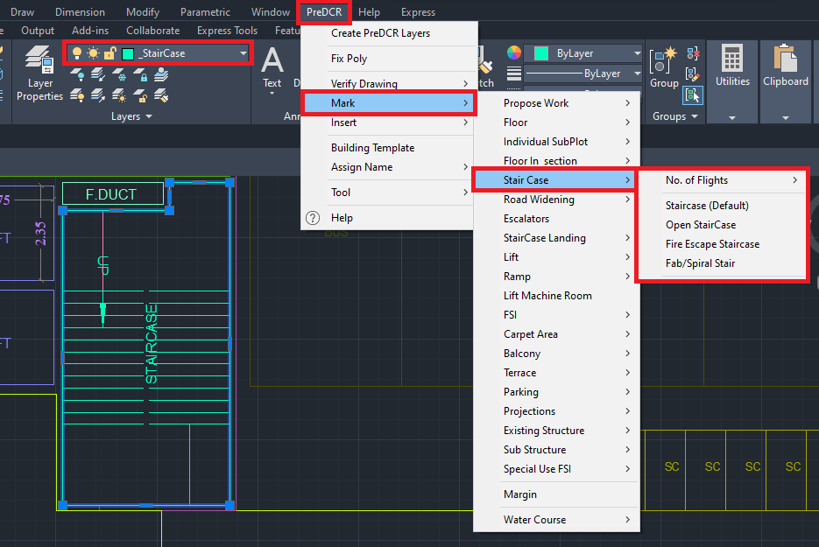

- For marking of staircase intermediate landing, flight width, and floor landing:
- Go to PreDCR menu Select ‘Mark’ Select ‘Staircase Landing’ Select ‘Intermediate landing’.
- Go to PreDCR menu Select ‘Mark’ Select ‘Staircase Landing’ Select ‘Flight Width’.
- Go to PreDCR menu Select ‘Mark’ Select ‘Staircase Landing’ Select ‘Floor Landing’.

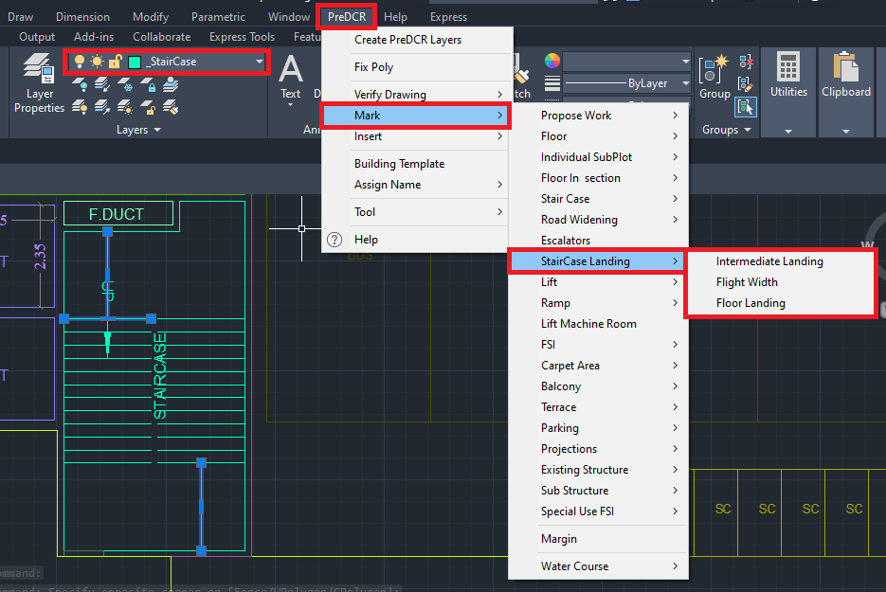

- To insert stair Up/DN direction:
Go to PreDCR menu Select ‘Mark’ Select ‘Stair Up/DN’ Select ‘UP/DN’.

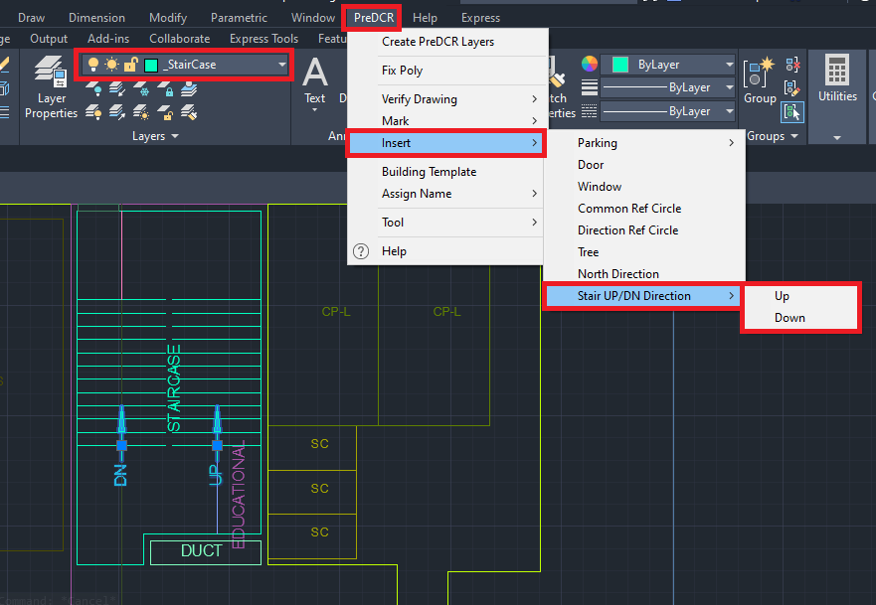
4.2.6. How to draw the ‘_Room’ layer?
- Go to layers drop down Select the ‘_Room’ layer.
- Draw every room in a closed polyline on the ‘_Room’ layer.
- To assign ‘Room’ name ‘_Room’ layer:
Go to the PreDCR menu Select ‘Assign Name’ Select ‘Room’ use name From the list of room names For ex: Select ‘Class Room’/Staff Room’.
As per the proposed plan.

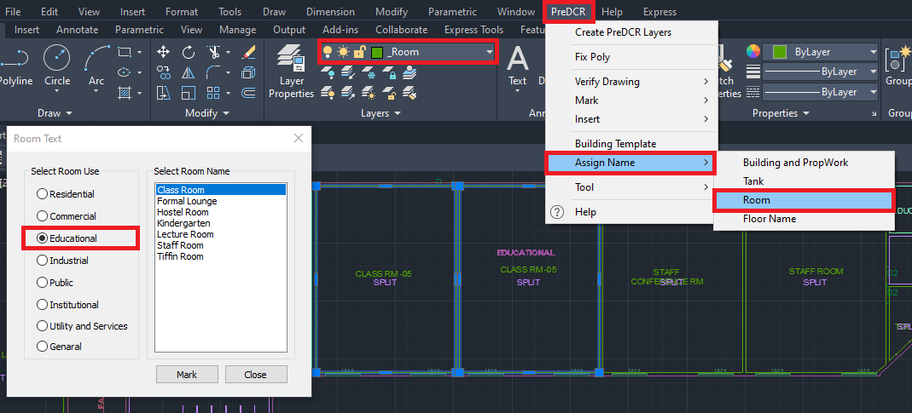

4.2.7. How to draw the ‘_CarpetArea’ layer?
- Go to layers drop down Select the ‘_CarpetArea’ layer.
- Draw carpet outline in closed polyline on the ‘_CarpetArea’ layer.
- ‘_CarpetArea’ layer represents the carpet area of the tenement/dwelling unit area.
- For marking the ‘_CarpetArea’ layer:
Go to the PreDCR menu Select ‘Mark’ Select ‘Carpet Area’ Select ‘Normal (Default)’.
To give tenement numbers OR name (Ex. ClassRoom,…) edit carpet text.
Options available to mark the Carpet Area:
Go to menu bar PreDCR MarkCarpet Area Splited Tenement
Go to menu bar PreDCR MarkCarpet Area Slum development Rehab OR Sale
Go to menu bar PreDCR MarkCarpet Area Normal (Default).

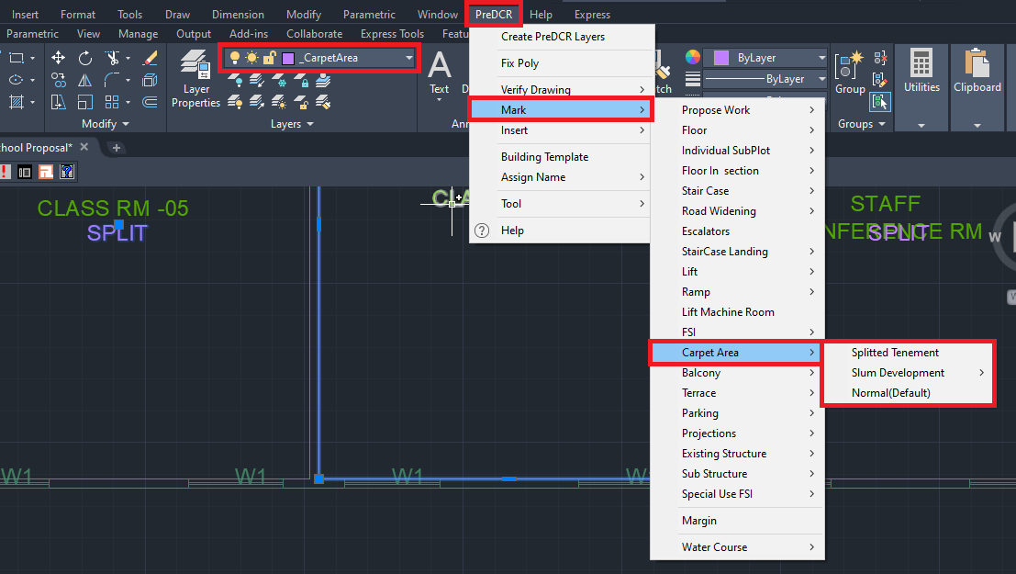

4.2.8. How to insert the door on the ‘Door’ layer?
- Go to layers drop down Select the ‘Door’ layer.
- To insert doors on the ‘Door’ layer:
Go to the PreDCR menu Select ‘Insert’ Door.

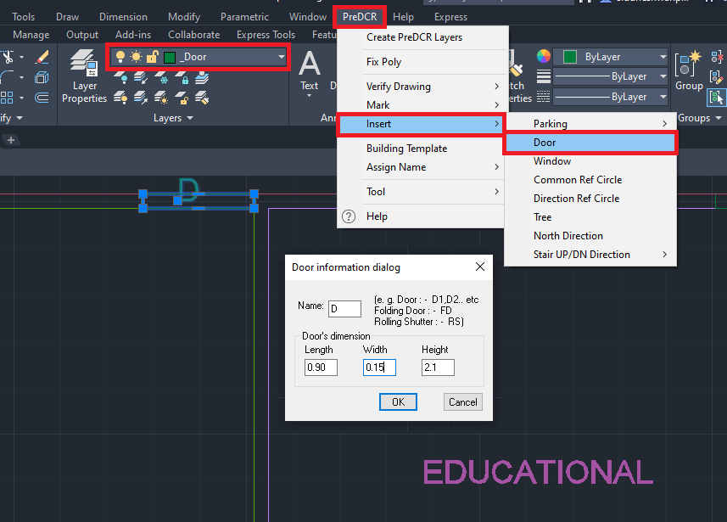
- In the ‘Door Information Dialog’ box fill in the information:
For ex: ‘Width’=0.90m, ‘Depth’=0.15m, ‘Height’ =2.10m and ‘Name’ = D as shown.
Insert the door as per the requirement
Similarly, insert ‘Rolling Shutter’ and fill up information in the dialog box as per the proposal:
For ex: ‘Width’=2.70m, ‘Depth’=0.15m, ‘Height’ =2.10m and ‘Name’ = R/S.
For rolling shutter in ‘Name’ = ‘R/S’ is filled up instead of ‘D’.

4.2.9. How to insert a window on the ‘_Window’ layer?
- Go to layers drop down Select ‘_Window’ layer.
- To insert doors on the ‘_Window’ layer:
Go to the PreDCR menu Select ‘Insert’ Select ‘Window’.
Fill up window information in a dialog box:
For ex: ‘Width’ = 1.80m, ‘Depth’=0.15m, ‘Height’=1.50m and ‘Name’ =W1.
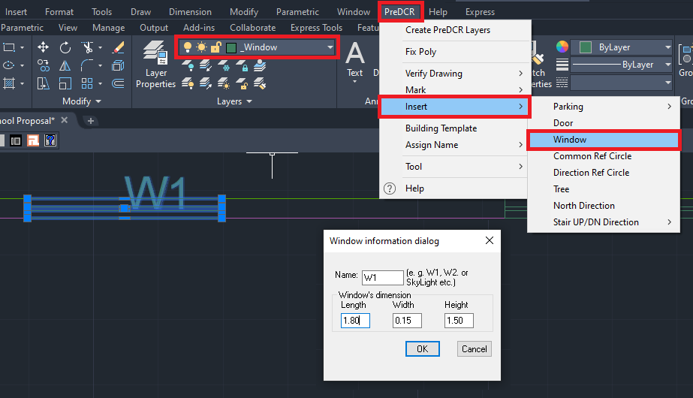
Similarly, insert ‘Ventilator’ and fill up the information as per requirement.
For ex: ‘Width’ = 0.6 m, ‘Depth’=0.23m, ‘Height’=1.2 m and ‘Name’ = V as shown.
For the ventilator in ‘Name’ = ‘V’ is filled up instead of ‘W’.

4.2.10. How to draw service duct on the ‘_Void’ layer?
- Go to layers drop down Select ‘_Void’ layer.
- Draw duct outline in closed polyline on the ‘_Void’ layer.
- Give the MText as ‘Service Duct, Ele. Duct, etc

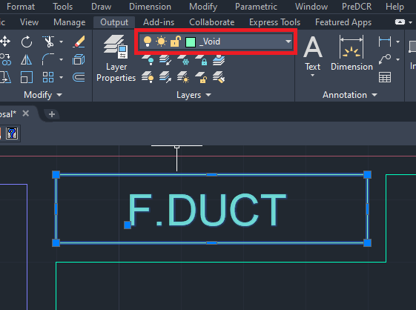
4.2.11. How to draw the ‘_Passage’ layer?
- Go to layers drop down Select the ‘_Passage’ layer.
- Draw a passage outline in a closed polyline on the ‘_Passage’ layer.
- Give the MText as ‘Passsge’ OR ’2.40m Wide Passage’.

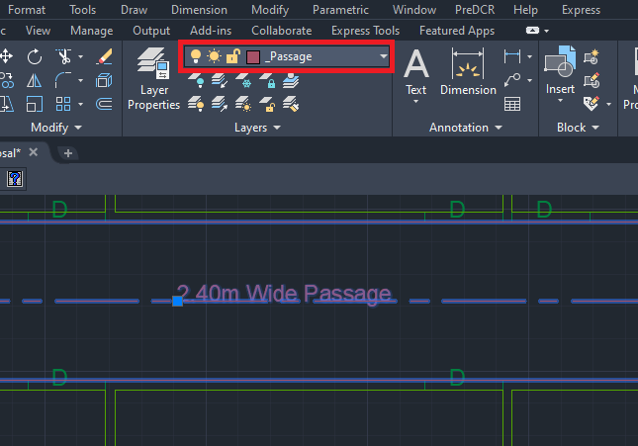
4.2.12. How to draw a habitable floor on the ‘_Floor’ layer?
- Go to layers drop down Select ‘_Floor’ layer.
- Draw floor plan outline in closed polyline on the ‘_Floor’ layer.
- ‘_Floor’ layer poly should be drawn outside/all around the converted floor plan.
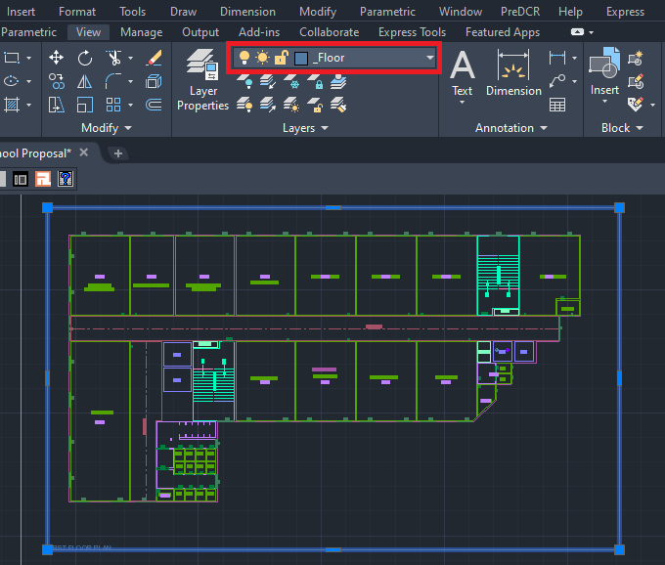
NOTE:
‘Common Reference Circle’ and ‘Direction Reference Circle’ should be inserted in all the floor plans the on ‘_FSI’ layer and ‘_Floor’ layer respectively in the same location as of other floor plans. Please refer 4.1.5 and 4.1.6 sections.
Similarly, convert the remaining habitable floor plans.

4.2.13. How to draw a terrace floor on the ‘_Terrace’ layer
- Go to layers drop down Select ‘_Terrace’ layer.
- Draw terrace floor plan outline in closed polyline on the ‘_Terrace’ layer.
- For marking of the ‘_Terrace’ layer:
Go to the PreDCR menu Select ‘Mark’ Select ‘Terrace’Common Terrace/ Individual
Terrace.

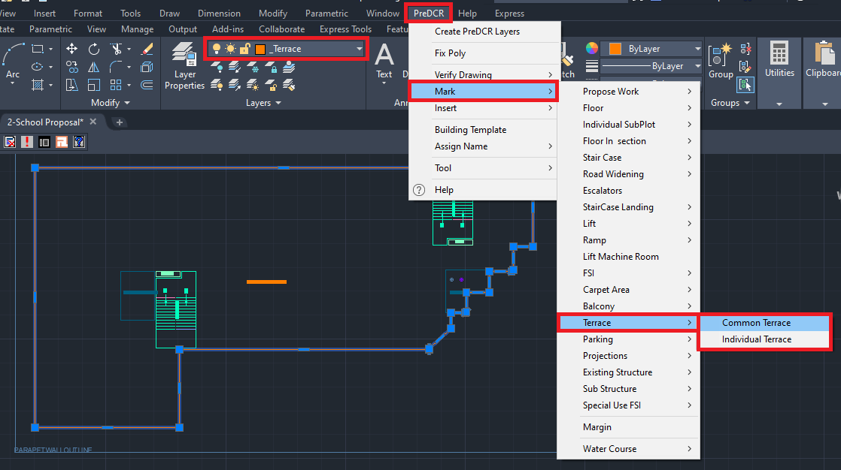

4.2.14. How to draw the lift machine room ‘_LiftWell’ layer?
- Go to layers drop down Select the ‘_LiftWell’ layer.
- Draw the lift machine room in a closed polyline on the ‘_LiftWell’ layer.
- For marking of ‘_LiftWell’ layer:
Go to PreDCR menu Select ‘Mark’ Select ‘Lift Machine Room’ Select both lifts well
poly drafted in ‘Floor Section’ and ‘Terrace Floor Plan’.

Lift machine room on terrace Lift machine room on section block
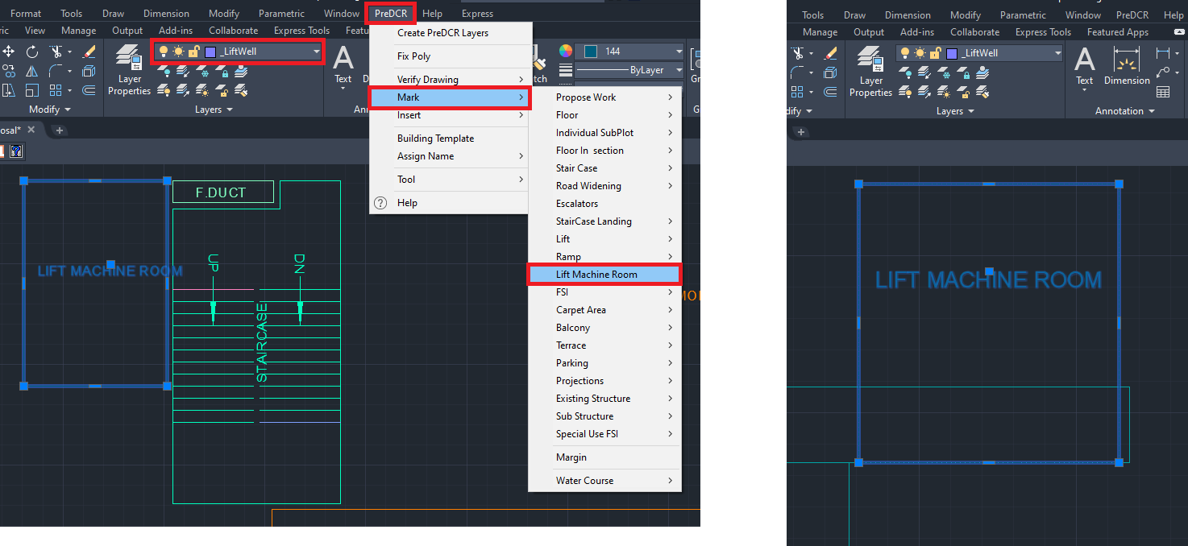

NOTE:
1) ‘Common Reference Circle’ and ‘Direction Reference Circle’ should be inserted in all the floor plans the on ‘_FSI’ layer and ‘_Floor’ layer respectively in the same location as of other floor plans. Please refer 4.1.5 and 4.1.6 sections.

2) Complete the floor plan by converting the staircase block. please refer 4.2.5 section for staircase block conversion.

  - Let’s start the Floor Section Conversion.

4.3.1. How to draw the floor section on the ‘_FloorInSection’ layer?
- Go to layers drop down Select the ‘_FloorInSection’ layer.
- Draw each and every floor in a closed polyline on the ‘_FloorInSection’ layer separately.

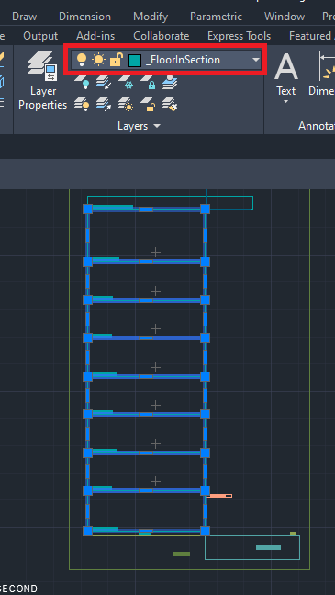
4.3.2. How to link floor section and floor plans?
- To link the floor in section to the floor in the plan.
Go to PreDCR Menu Select ‘Assign Name’ Select Floor Name/Nos.
Fill in the information in the ‘Auto Assign floor name’ dialog’ box:
‘Select floor name’ from a drop-down (for ex: Ground Floor)
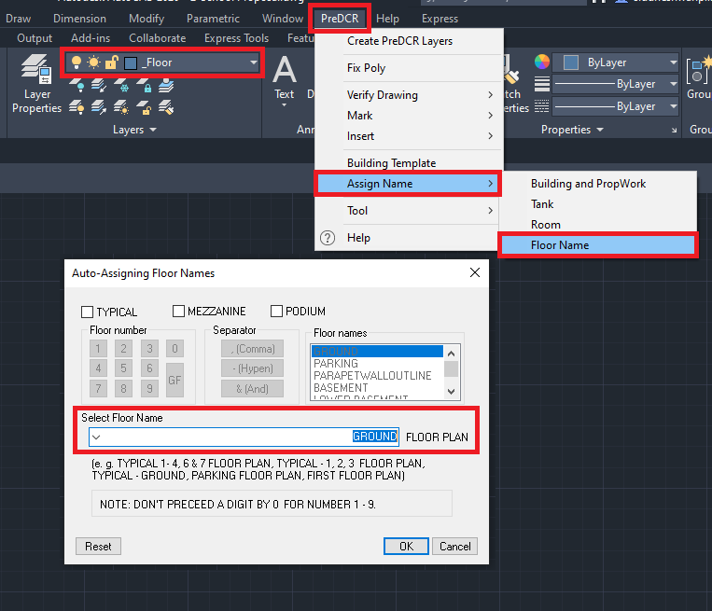

Select ‘OK’, then select the corresponding floor poly and floor in section poly in the drawing Ground Floor is selected in the plan and section.
Only ‘Plinth’ need to Mtext in the section.

- To continue the floor assign name, select ‘Yes’ and follow the process as follows:
Fill in the information in the ‘Auto Assign floor name’ dialog’ box:
‘Select floor name’ from a drop-down (for ex: First Floor Plan)
Select ‘OK’, then select the corresponding floor poly and floor in section poly in the drawing First Floor is selected in plan and section.

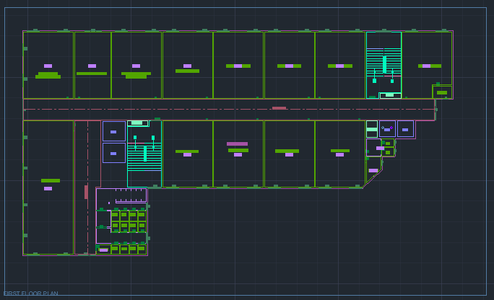

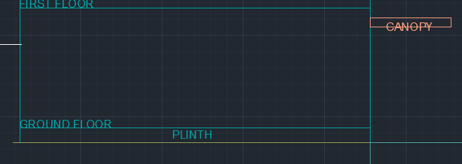

- To assign a name to a typical floor, select ‘Yes’ and follow the process as follows:
Fill in the information in the ‘Auto Assign floor name’ dialog’ box:
Select the check box of ‘Typical’
Select floor no.
Select separator
Select another floor no.
Select ‘OK’
Select floor poly in section (First and Second floor) and corresponding floor plan.
- To assign a terrace floor name, select ‘Yes’ and follow the process as follows:
Fill in the information in the ‘Auto Assign floor name’ dialog’ box:
‘Select floor name’ from a drop-down (for ex: Terrace floor)
Select ‘OK’, then select the corresponding floor poly and floor in section poly in the drawing Ground floor is selected in the plan and section.
The floor Plan will be automatically linked with the Section Floor by matching the Floor Name.

4.3.3. How to draw the Staircase Headroom in the ‘_Staircase’ layer?
- Go to layers drop down Select the ‘_Staircase’ layer.
- Draw staircase headroom in closed polyline on the ‘_Staircase’ layer.
- Give the MText as ‘Staircase OR Staircase Head Room’.

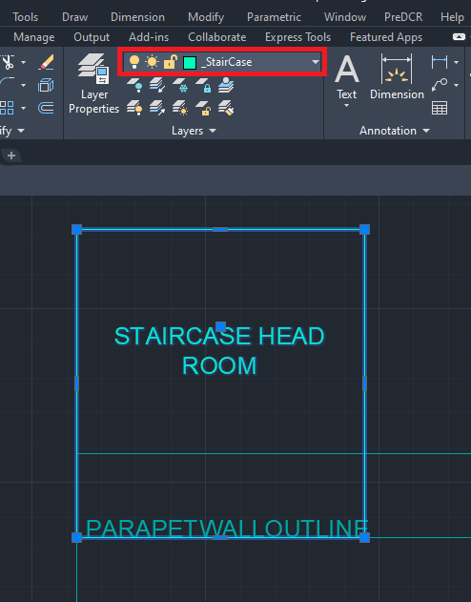

Refer to the 4.2.14 section to draw the lift machine room in a closed polyline on the ‘_LiftWell’ layer in Sectio Block.

4.3.4. How to draw ground level in the ‘_GroundLevel’ layer in Floor Section?
- Go to layers drop down Select the ‘_GroundLevel’ layer.
- Draw the Ground level line as per polyline on ‘_GroundLevel’ layer.
- Give ‘MText’ as ‘Ground Level ‘.

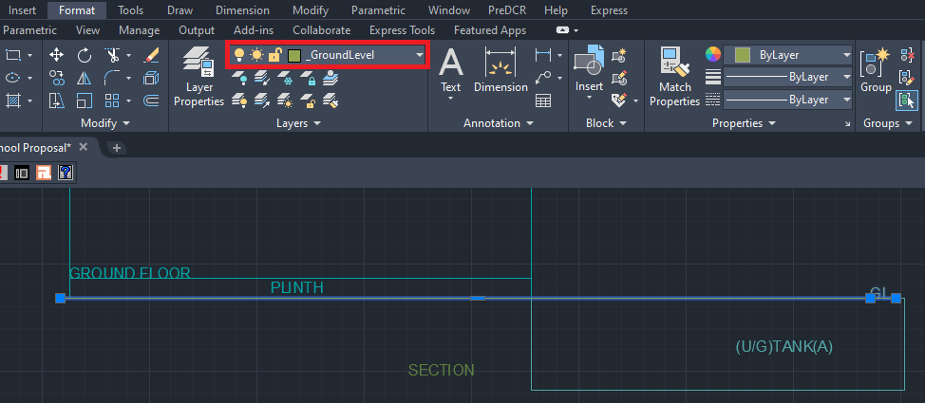

4.3.5. How to draw section details ‘_Section’ layer?
- Go to layers drop down Select ‘_Section’ layer.
- Draw ‘_Section’ layer poly to group all floors in section, lift machine room, staircase head room and tank details.
- Give ‘MText’ as ‘Section‘.

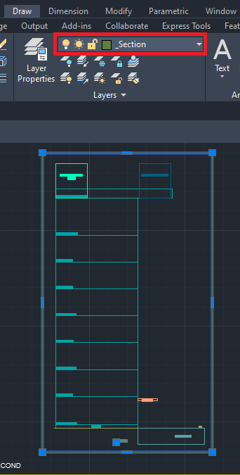

4.3.6. How to draw print additional details items in the ‘_PrintadditionalItem’ layer?
- Go to layers drop down Select ‘_PrintadditionalItem’ layer.
- Draw all architectural details (like Septic tank details, RWH Details, and Compound Wall Details) on the ‘_PrintAddtionalDetail’ layer.

4.3.7. How to draw elevation on the ‘_Elevation’ layer?

- Go to layers drop down Select ‘_Elevation’ layer.
- Draw every side elevation on ‘_Elevation’ layer OR you can can change elevation layer architecural layer to PreDCR ‘_Elevation’ layer.

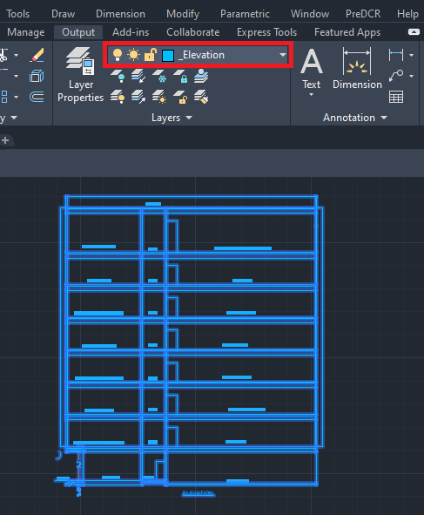

4.3.8. How to draw floor plans, section, elevation, and print additional details inside the ‘_Building’ layer?
- Go to layers drop down Select ‘_Building’ layer.
- Draw ‘_Building’ layer poly to group all floor plans, section, elevation and print additional details of the same Building.

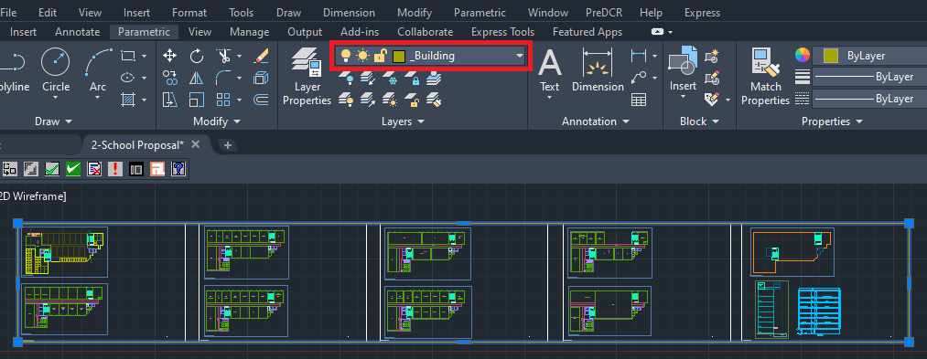

4.3.9. How to link the building plan to PWork?
- To link building plan to Pwork.
Go to PreDCR menu-Select ‘Assign name’ Building and Propwork.
Select ‘Building poly’ in the drawing.
Fill up the ‘Building and Propwork Name’ dialog box:
Fill up ‘Wing Name’ and ‘Building Name’
Select Propwork in the drawing.
It will link the building plan to Pwork .

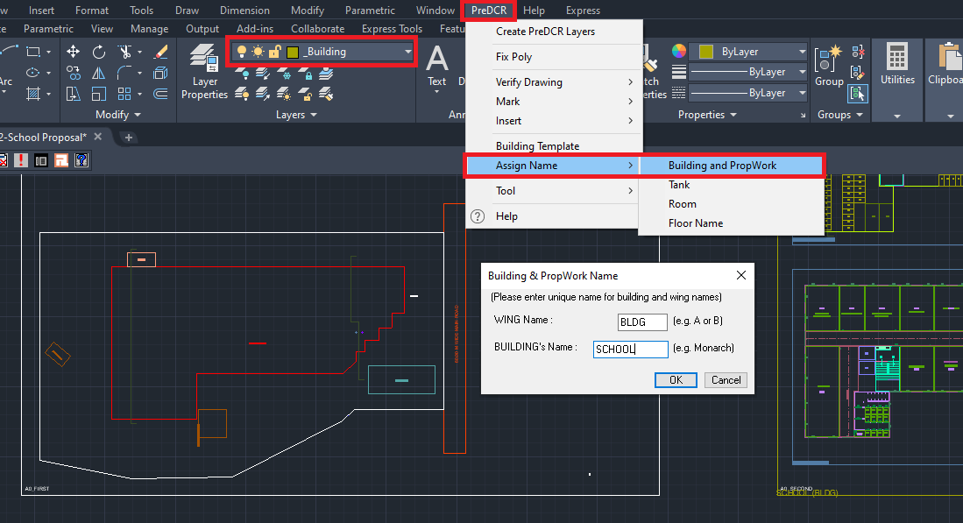

After completing the conversion proceed to the next tab of the PreDCR toolbar:

- How to Fix Poly?
This command is used once the complete drawing conversion is done. This tab will check all the polylines on the PreDCR layer and remove extra vertices found on polylines or duplicate entities. This command should be used (before verifying the drawing) every time you add any new entity to the drawing.
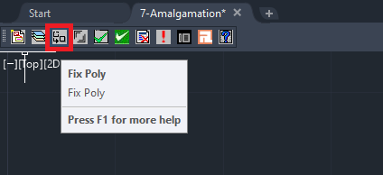
- How to Mark the Margin?
- Click on the ‘Mark Margin’ tab to open a dialog for mark margin.
In the dialog box:
Select ‘Front’Select from margin on site plan
Select ‘Side’Select both side margin on site plan
Select ‘Rear’Select rear side margin on site plan
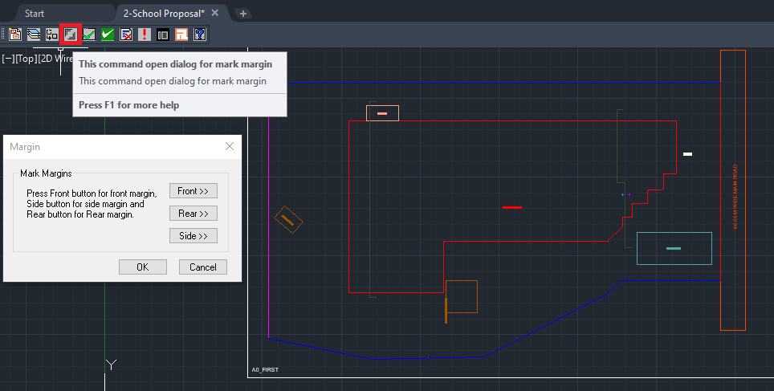

- How to Verify close Poly?
This command will verify the current drawing as required by AutoDCR. It will verify that
LWPOLYLINE entities on the selected layers are closed and contain one text.
Shows ‘Select layer box’ select ‘Ok’.

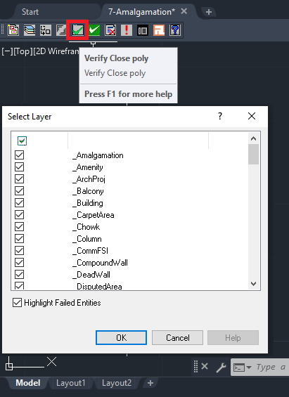

- How to Verify the Current Drawing?
This command is used to verify the layout and building-level objects in the current drawing plan.
- Check if these entities are drawn as closed LWPOLYLINE.
- Name text is given to all objects.
- Entities are placed exactly inside their parent objects (container).
- Naming conventions are followed properly.
In the "Verify All Drawing Dialog" you can select the layout or building objects to be checked. To view the result, press the OK button.
Select ‘OK’ - Entity not found list dialog box.
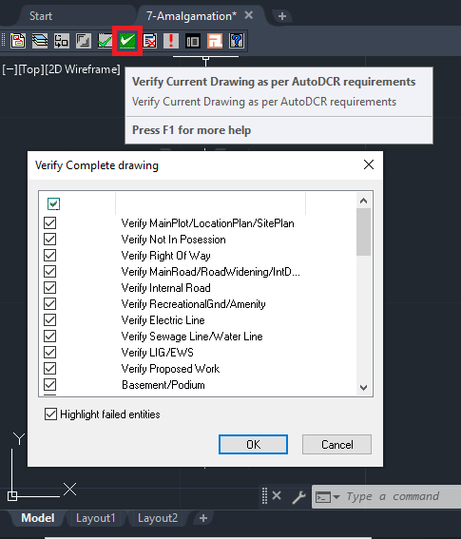
PreDCR will start checking all corresponding objects in the currently open drawing and then display the status as OK or list of failed objects with the reason of failing in the dialog as shown.

- How to view the ‘PreDCR Report’?
- Click on Show failed entity report.

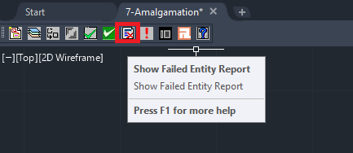

This command will generate the PreDCR report and having area details of the drawn entities in the drawing. All the verified and failing entities having Information will be shown in this Report.

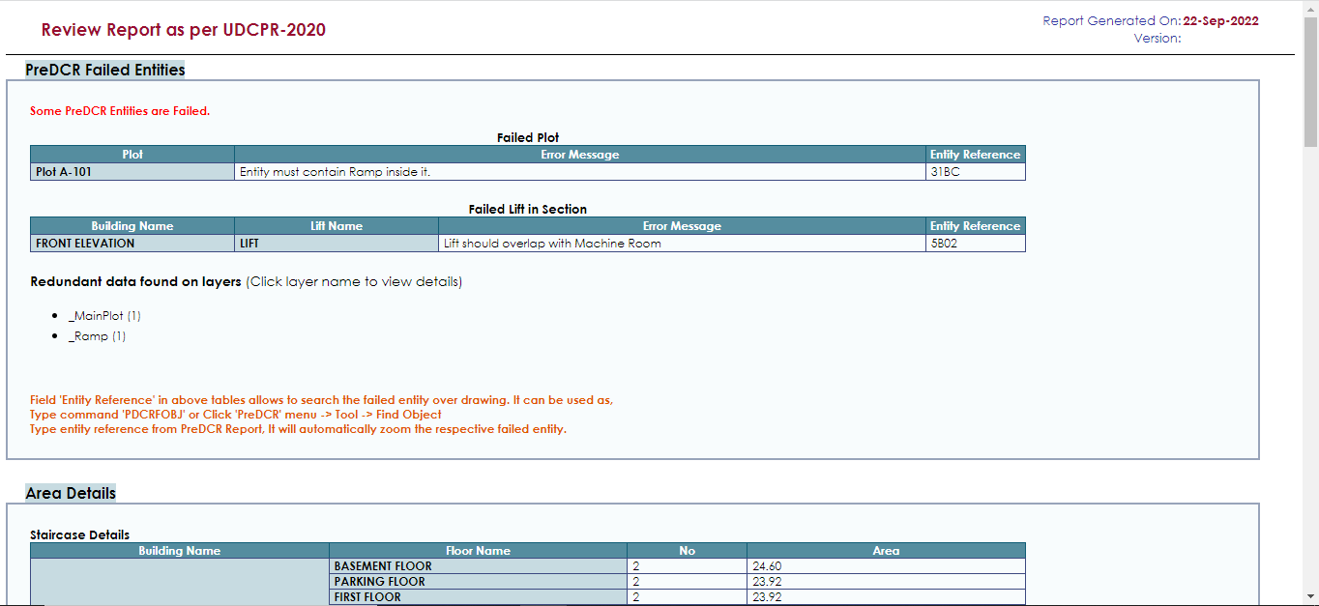

- How to use the ‘Show Objection List’ tab?
This command gives the list of all minimum required entities that are not there in your drawing. If all required entities are found then it gives a message that minimum required entities are present in drawing.

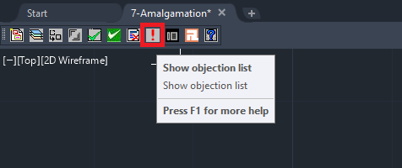

- How to map architectural layers with PreDCR MH layers?
- Click other ‘Layer mapping for current drawing’ tab
- This is to map the architectural layers with PreDCR layers.

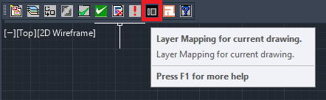
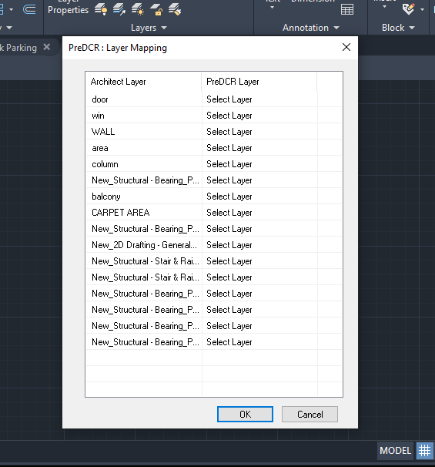
- How to view active help?
- Click on ‘Active Help’ tab for quick help regarding PreDCR layers.
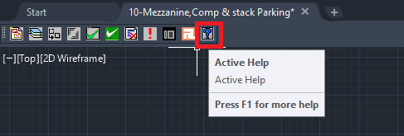


This is the last page of the document.
Thank You.

